IN Scikit learn we have implementation for different type of NB and one of them is Out of core NB

IT means when your data is very large break it into chunks and use one chunk and a time to compute your probs and update those values using second chunk and so on.

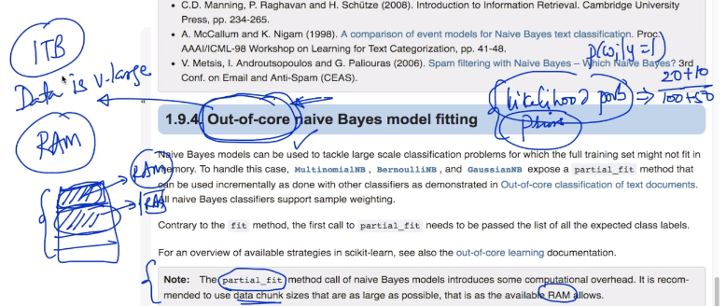

Scikit learn NB documentation:

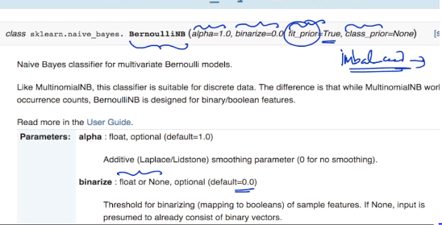

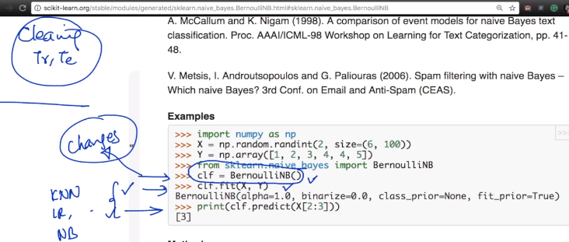

It is really one line of change to move from one model to another model as we know that scikit learn provides every model needed we need.

The whole fight in Machine Learning is really between Over Fitting and Under Fitting of a model and so coding is not the tough part in Machine learning but understanding the model is , to understand in which case it falls

And how to handle is the tough part.